# Project Title : Neo Banking System

(By SEMESTER – V of III Year M.Sc.(CA & IT) 2022-23)

Submitted By :

|  |  |
| --- | --- |
| Student Name | Roll No. |
| Harsh Vinod Bhai Gajjar | 3020 |
| Aakash Dharmesh Bhai Pavar | 3057 |
| Bharat Umaji Prajapati | 3058 |

Group ID : 12

Name of Company : TechCrave Solutions Pvt Ltd

Date of Submission : 10-12-2023

Submitted To

K. S. School of Business Management

M.Sc. - Computer Applications and Information Technology.

## Acknowledgement

I would like to express our thanks to the people who have helped us most throughout our project. We are grateful to our internal guide VIJAYBHAI SUVAGIYA sir for nonstop support for the project. A special thanks of our goes to the SKY TOUR & TRAVEL who helped us by providing their support to us. Their continuous help & support made the project much easy. We also express our sincere thanks to all our friends & beneficial who helped us throughout this project.

# Index

|  |  |
| --- | --- |
| Details | Page No |
| Chapter 1. Introduction |  |
| * 1.1 :- Organization Profile |  |
| * 1.2 :- System Details |  |
| 1.2.1 :- Existing System |  |
| 1.2.2 :- Proposed System |  |
| * 1.3 :- Scope of System |  |
| * 1.4 :- Objectives |  |
| Chapter 2. Proposed System Requirement Gathering |  |
| * 2.1 :- Stack Holders of System |  |
| * 2.2 :- Requirement Gathering Technique Used |  |
| * 2.3 :- Consolidated List of Requirements |  |
| * 2.4 :- Project Definition |  |
| Chapter 3. System Management and Planning |  |
| * 3.1 :- Feasibility Study |  |
| 3.1.1 :- Technical Feasibility |  |
| 3.1.2 :-Economical feasibility |  |
| 3.1.3 :- Operational feasibility |  |
| * 3.2 :- Hardware and Software Requirement |  |
| * 3.3 :- System Planning |  |
| 3.3.1 :- Work Break Down Structure |  |
| 3.3.2 :- GANNT Chart |  |
| * 3.4 :- Process Model |  |
| Chapter 4. System Analysis and Planning |  |
| * 4.1 :- UML (Unified Modeling Language) |  |
| 4.1.1 :- Use Case Diagram |  |
| 4.1.2 :- Activity Diagram |  |
| 4.1.3 :- Class Diagram |  |
| 4.1.4 :- Sequence Diagram |  |
| * 4.2 :- System Flow Diagram |  |
| * 4.3 :- Data Dictionary |  |
| * 4.4 :- User Interface |  |
| * 4.5 :- System Navigation Diagram |  |

# CHAPTER – 1 : INTRODUCTION

# 1.1: Company Profile

* Company Name : Tech Crave Solutions(OPC) Pvt Ltd
* Company Address : Ahmedabad , Gujarat-382470.
* Specialities : Mobile application, Website,

Web services.

* Founded : April , 2021 .
* Contact : [+919377630883](tel:+919377630883)
* E-mail : vishaltanna.professional@gmail.com

# 1.2 : System Details

## 1.2.1 : Existing System :-

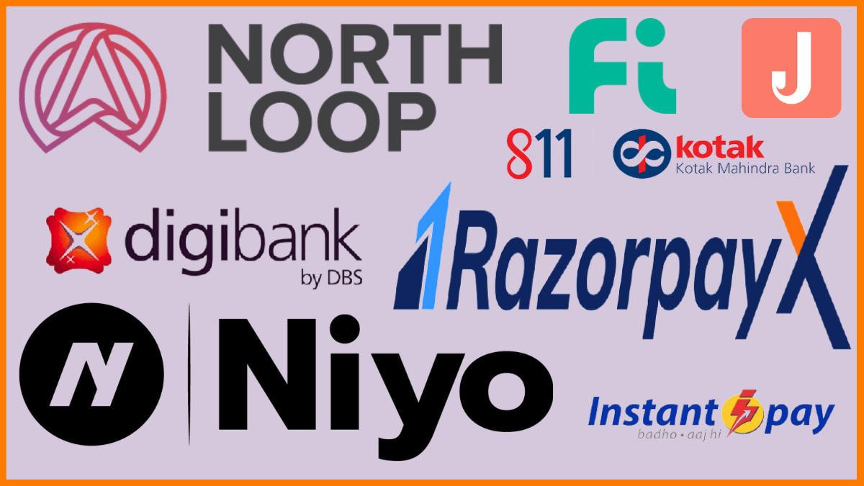Traditional banks, while serving as essential pillars of the financial system for centuries, have faced various challenges and problems over time.

* High Operating Costs : - Traditional banks often have significant overhead costs associated with maintaining physical branches, staffing, and administrative expenses.
* Limited Accessibility : - Physical branches have limited hours of operation and may not be easily accessible to all customers, especially those in rural or remote areas.
* Regulatory Compliance Burden : - Traditional banks are subject to a complex web of regulations, which can result in compliance costs.

There are many Neo Banks are working in India such as Jupiter Bank, Fi Money, Freo, InstantPay, FamPay, RazorpayX etc.

## 1.2.2 : Proposed System :-

* A new type of bank called a Neo Bank is coming into the banking world. It wants to change how banking works, making it easier and more helpful for anyone.
* With our Neo Bank, we aim to break free from the constraints of traditional banking. Say goodbye to long queues at branches, complex paperwork, and hidden fees.
* We're here to provide you with a hassle-free, transparent, and accessible banking experience.

Promises to eliminate traditional constraints

* Long queues at branches.
* Complex paperwork.
* Hidden fees.

The Neo bank system is a revolutionary approach to banking that has changed the traditional financial approach.

Unlike traditional banks with physical branches, Neo banks are fully digital financial institutions that operate exclusively through web and mobile applications.

# 1.3 : Scope of the System

* Our System typically offers a limited range of products and services, such as savings accounts, checking accounts, debit cards, and loans. However, they focus on providing these products and services in a way that is easy to use and accessible to everyone.
* We are an online-only bank using technology to offer users a convenient, affordable, and personalized banking experience.
* Communicate with potential customers 24/7. We work hard to understand what people today want and need from a bank. We also come up with cool and unique ways to help with money stuff, and they let you customize your banking experience.
* Customer can view their account online. Customer can also make payment online.
* Neo banks are still a relatively new phenomenon, but they are growing rapidly. The global neo bank market is expected to reach $333.4 billion by 2026. This growth is being driven by the increasing popularity of digital banking, as well as the growing demand for more convenient, affordable, and personalized financial services.

# 1.4 : Objectives of System

* **Digital Convenience**: Neo banks aim to provide a seamless and user-friendly digital banking experience, allowing customers to open accounts, conduct transactions, and manage their finances entirely through mobile apps or web platforms.
* **Financial Inclusion**: Many neo banks target underserved or unbanked populations, seeking to provide accessible and affordable banking services to individuals who may have limited access to traditional banking options.
* **Fast and Easy Account Opening**: Neo banks strive to simplify the account opening process, making it quick and straightforward for customers to sign up and start using their services.
* **Enhanced Customer Experience**: Providing excellent customer service and support is a key objective for neo banks, as they seek to differentiate themselves from traditional banks and foster strong relationships with their customers.
* **Continuous Improvement and Innovation**: Neo banks prioritize continuous improvement and innovation to stay at the forefront of technology and offer cutting-edge banking solutions.
* **Financial Education**: Some neo banks focuses on educating customers about financial matters. Their objectives are to promote financial literacy and empower customers to make decision about their money.
* **Paperless and Eco-Friendly Approach**: Neo banks often emphasize a paperless and eco-friendly approach to reduce their environmental impact. Their objective is to conduct all banking processes digitally, from account opening to transaction records.
* **AI-Powered Customer Support**: Neo banks may use artificial intelligence to enhance customer support and provide prompt assistance. Their objective is to resolve customer queries efficiently and offer a personalized support experience.
* **Loan and EMI** :- In a Neo banking system, loans and EMIs (Equated Monthly Installments) are typically offered as part of their suite of financial products.
* Loan Offers :-
  + Personal Loan
  + Special loan on Goods

# CHAPTER - 2 : PROPOSED SYSTEM REQUIREMENT GATHERING

## 2.1 - Stack holders of System :

* Admin/Employee :- Admin/Employee involved in user management, risk management (like managing risk and fraud prevention), transaction monitoring, customer support, product management , Technical Support , Account Management.
  + Only Admin can do :
    - Loan Management
    - Investment Management
* Customer :- Account opening, perform transactions, apply for loans
* Visitor:- Visit the website
* Investors :- Equity investment , Manage investments , View Financial Activities.

Every software project goes through up phase called requirement gathering. A successful project begins with a difficult set of discussion on what should be done. Its major responsibility of IT business analysis gathers the requirement from the client. Getting the correct requirement from the client can often be one of the biggest hurdles in any software project. If business analysis gathers correct and complete requirement, the project will yield richer crops.

## 2.2 - Requirement Gathering Technique Used :

* It’s difficult to build a solution if you don’t know the requirements. The “Elicitation” step is where the requirements are first gathered from the client. There are many techniques available for gathering the requirements. Each technique has value in certain scenario. Sometimes, It becomes necessary to use multiple techniques to gather complete and correct requirements from client and stakeholder.
* There are various ways to discover requirements some of them are **Interview**, **Questionnaires**, **Observation**, Prototyping. Interview is the primary source of requirement gathering and in order to do it successfully interviewer have to ask both open and close ended questions. Questionnaires are used when stakeholders are geographically distributed. Observation is used when stakeholders are not able to explain their requirements. Prototyping is iterative technique and cannot complete without one of the above techniques. In our system we are going to use the Questionnaires because of this we are able to ask multiple questions to the Stakeholders for client purpose.

## 2.2.1 : Interview

* ***We had held an interview with the owner of the organization for the requirements of our system and the following questions asked.***

1 What is the target market for the neobank?

* Small businesses

2 What are the main objectives of your Neo Bank system project?

* The main objective of our neo bank system is to do things online that are currently running offline, like online account openings, etc.

3 What are the demographics of the target market?

* Demographics include age, location, education, background, and their ideas, etc.

4 What are the security and compliance requirements for the neobank?

* Requirements include the number of accounts opened, the number of transactions processed, and the customer satisfaction rate.

1. Are there specific banking regulations or compliance requirements that we need to address?

* Yes, there are specific banking regulations and compliance requirements that apply to neo banks, such as KYC (Know Your Customer) and AML (Anti-Money Laundering) regulations.

6. How will users be able to transfer money within the neo bank system?

* Using online money transfer.

7. What problems do neo banks solve?

* Neo banks solve problems such as lower fees, competitive exchange rates, and transparent pricing structures.

8. What are the services offered by neo banks?

* Services include savings accounts, debit/credit cards, money transfer, special loans, etc.

9. How will customer support and communication with users be facilitated through the neo bank system?

* Via chat box support or via email.

10. What is the maximum limit for transferring money?

* You can transfer a maximum of Rs. 1, 00,000 in a day.

11. What are the primary goals of the bank for its users?

* Primary goals include providing access to financial services, helping users save money, and manage their finances effectively.

12. Do we plan to provide educational resources to users on how to use our neo bank services effectively?

* Yes, we plan to provide educational resources like FAQs, videos, and guides.

13. How will the neobank raise capital and fund its operations?

* Neo banks can raise capital through self-funding, using their own money or the money of their founders.

14. How will customer data be collected and managed within the Neo Bank system?

* Customer data will be collected via registration forms and business details and managed within our databases.

## Questions Asked in Interview for Requirement Gathering :

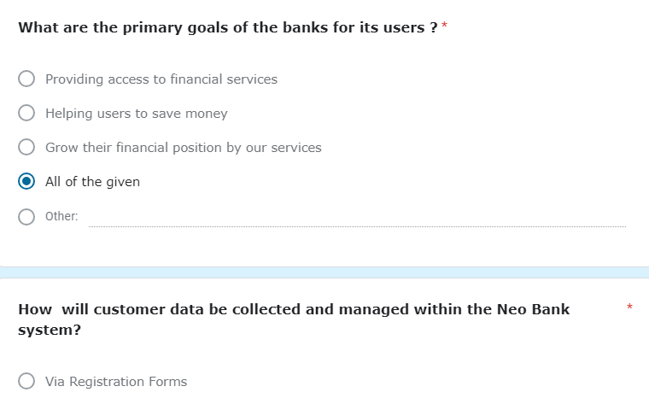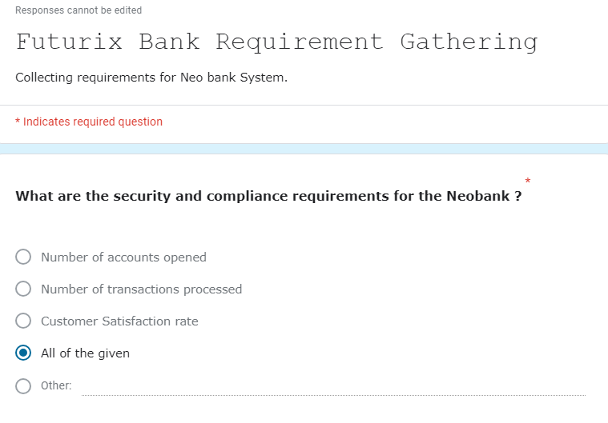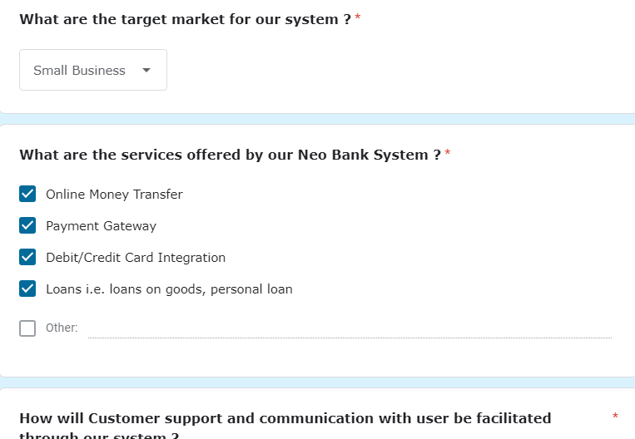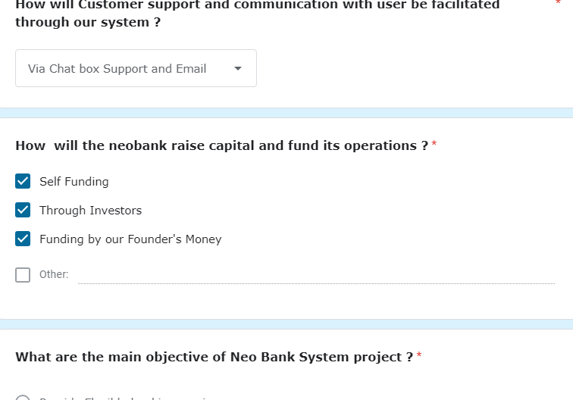



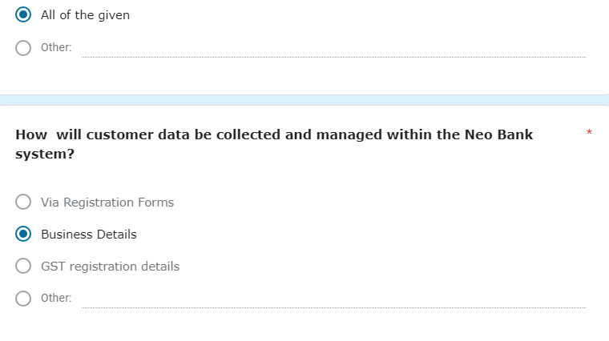

## 2.3 - Consolidated List of Requirements :

* Signup or Login using OTP.
* Enable efficient account creation and verification processes.
* Customer can open Account online , can make payments , apply for loan , check account related details via website.
* Special loans for small businesses.
* Admin can manage overall website and generate the reports also.
* Communicate with potential customer 24x7 through the chat Box.
* Registration through GST number for small businesses.
* Creating a wallet feature for a neo bank involves several technical and functional requirements to ensure security, functionality, and user-friendliness
* Keeping track of EMI of running loans.
* Set transaction limits and spending controls for security.
* Effective notification integration is a critical aspect of the our neo bank, ensuring that users have a seamless and secure banking experience.

## 2.4 - Project Definition :

TITLE : FUTURIX BANK

* The Futurix Bank’s core aim is to break away from traditional banking limitations.
* Neo banks prioritize digital accessibility over physical branches.
* Operations primarily occur through online platforms rather than physical locations.
* Emphasis is placed on user-friendly interfaces, personalized services, and quick transactions.
* Neo banks adopt eco-friendly practices by reducing paper usage.
* Artificial Intelligence is utilized for effective customer support and personalized experiences.
* Lower operational costs result from the absence of physical branches.
* Neo banks offer faster, streamlined account opening processes.
* Reduced or zero fees for various services are provided.
* Universal accessibility is a priority, enabling transactions from anywhere with internet access.

# CHAPTER - 3 : SYSTEM MANAGEMENT AND PLANNING